Our Finnish 100 Year

Christmas Celebration
At the Oak Hill Country Club
840 Oak Hill Rd. Fitchburg, MA 01420
Saturday, December 9, 2017
12:00-5:00 PM
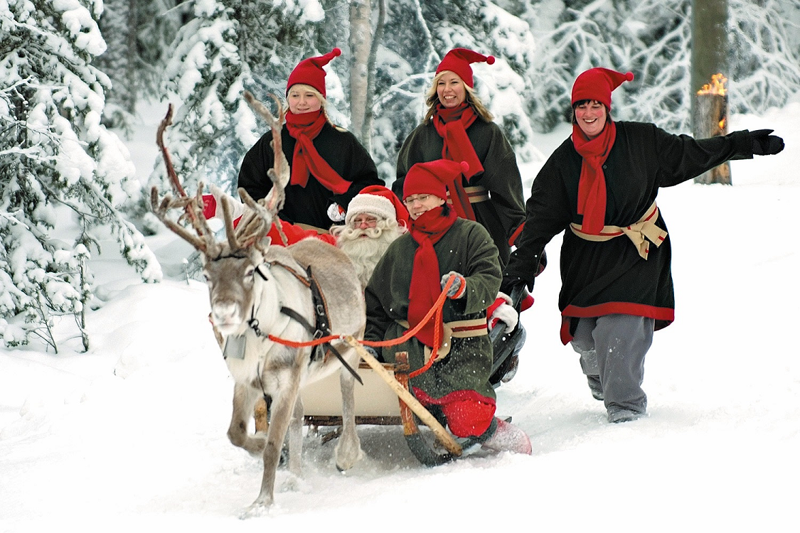
All are invited to enjoy a wonderful afternoon including videos of the Peace Proclamation
from Turku and Finnish Christmas scenes, Finnish Christmas carols played by Elisa Lomme,
speaker Roy Helander, dancing to music by Oivan Ilo, some historic information about the
evolution of Christmas traditions in Finland, and other surprise happenings
with a visit from a famous Christmas person.
---------------------------------------------------------------------------------------------------------------------------------
Please fill out the form below with the meal selection for each person attending
and mail with your check to Peter Heaney, 30 Davis St. Rutland, MA 01543
or call him at 508 886-6073 with your dinner selection. Make checks payable to FHSS

Deadline for Dinner reservations: November 28, 2017

Name: _______________________________________________Phone number____________________

Address________________________________________________________________________________

E-mail_______________________________ Please circle your choice of meal selection below

Name_________________________________: chicken $27 haddock $25 petite filet mignon $30

Name_________________________________: chicken $27 haddock $25 petite filet mignon $30

Name_________________________________: chicken $27 haddock $25 petite filet mignon $30

Name_________________________________: butternut squash ravioli & seasonal veggies $25.00

Name _________________________________: Child: chicken fingers OR mac & cheese $11

